

**“How to set UTF-8 as default Encoding for Text file”**

There are many ways by which we can set the encoding for text file to UTF-8

**Type 1:**

**Change your workspace settings**

To change the workspace setting to UTF-8 in Eclipse so any new projects you create will be using it by default open the Workspace Preferences dialog:

**Step 1:**

In the preferences dialog, change the encoding for everything in sight to UTF-8.

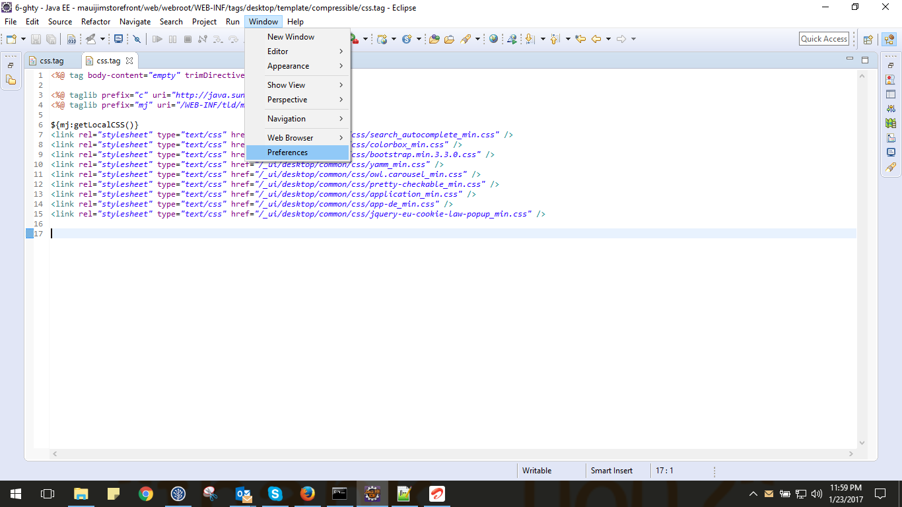

**Step 2:**

Now go to-> Window > Preferences > General > Workspace, set "Text file encoding" to "Other: UTF-8".

Set Text file encoding to Other: UTF-8.

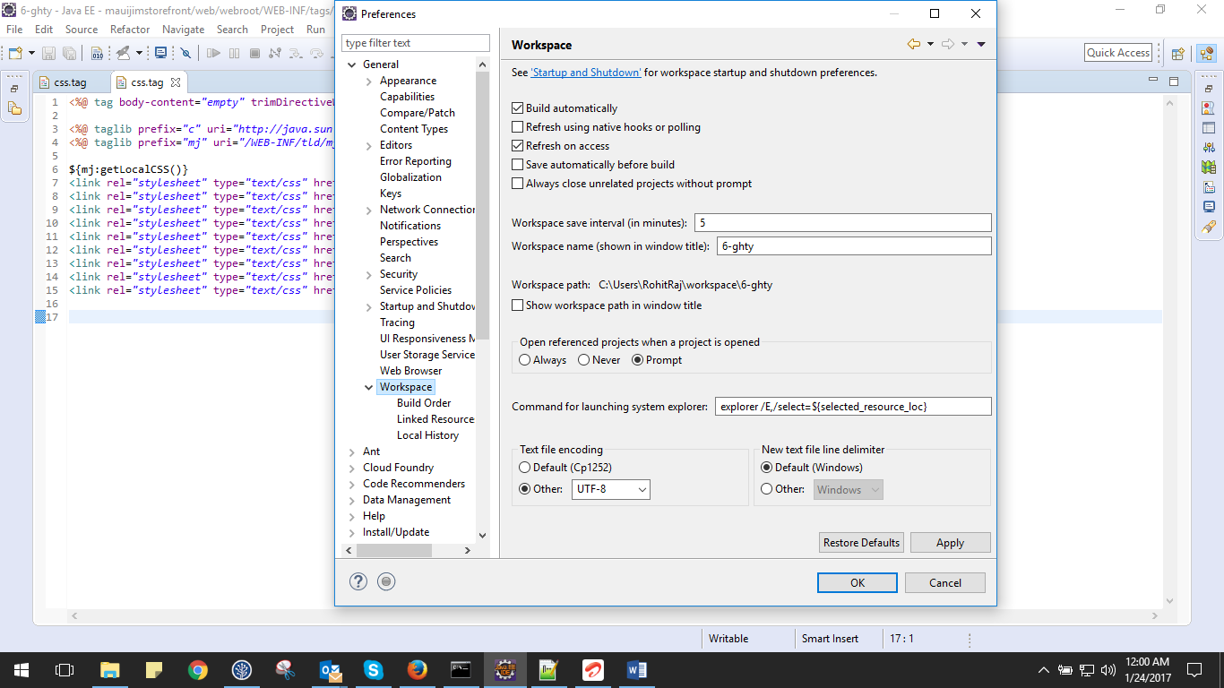

**Type 2:**

**Step 1:**

Window > Preferences > General > Content Types, set UTF-8 as the default encoding for all content types.

Set Text file encoding to Other: UTF-8.

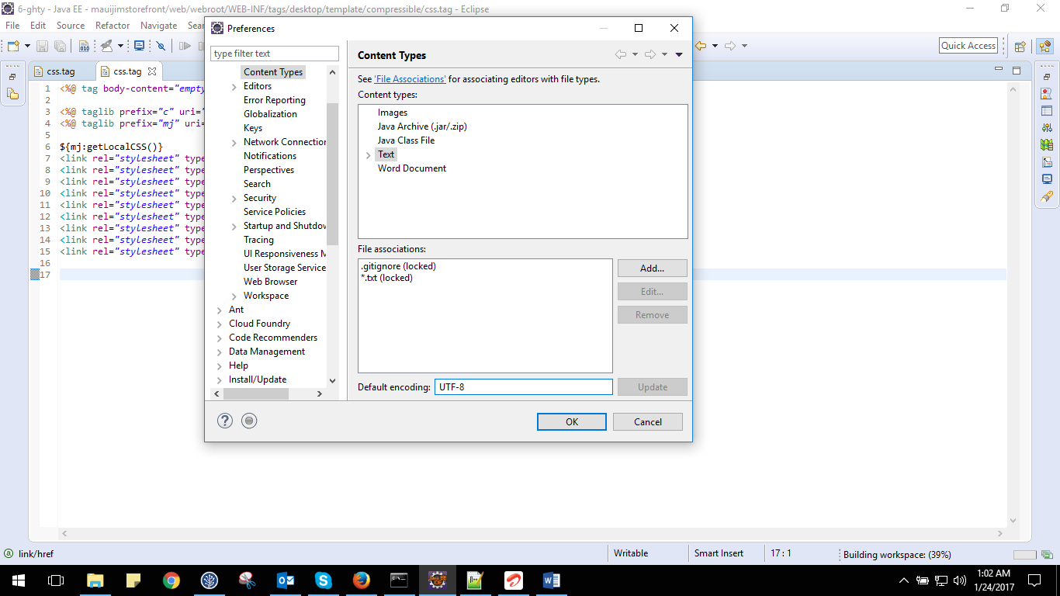

**Step 2:**

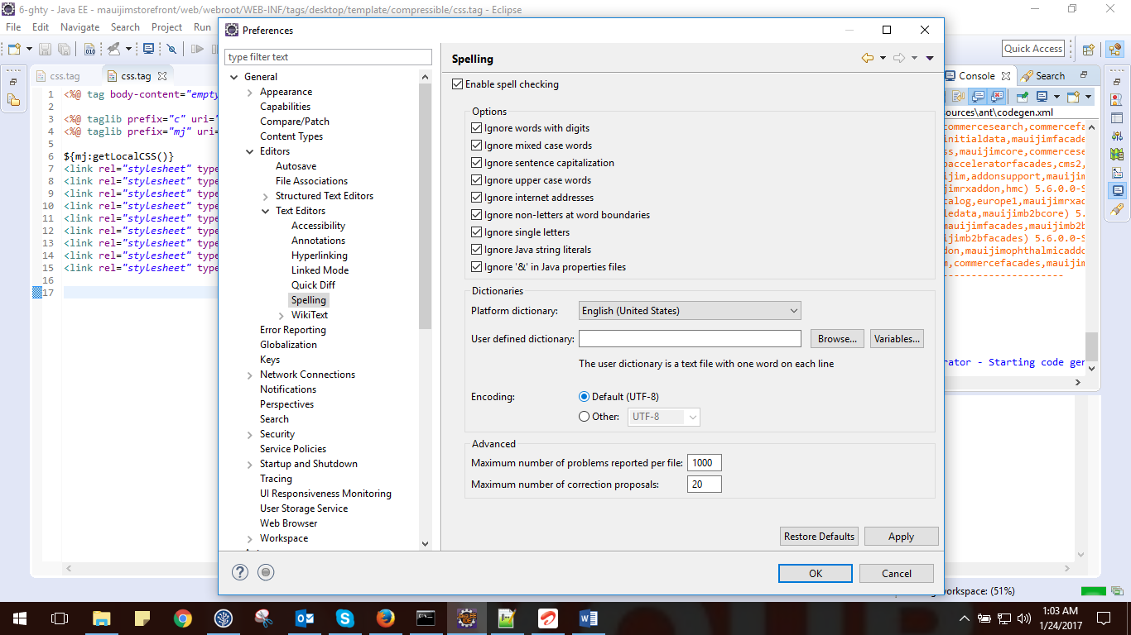

**Type 3:**

Just right click the Project -- Properties and select Resource on the left side menu.

You can now change the Text-file encoding to UTF-8.

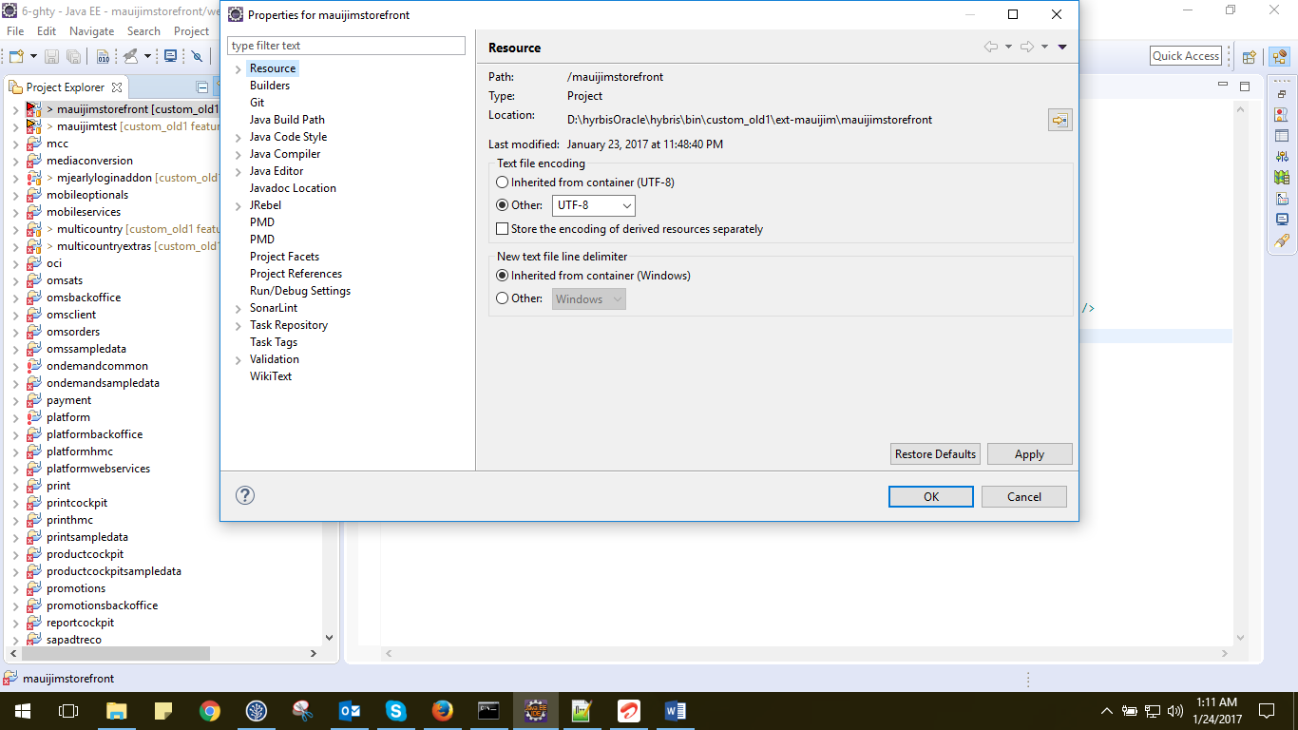

**NOTE PAD ++**

Step: Got to Encoding tab and selects the Encode in UTF-8 format. Refer to below screenshots

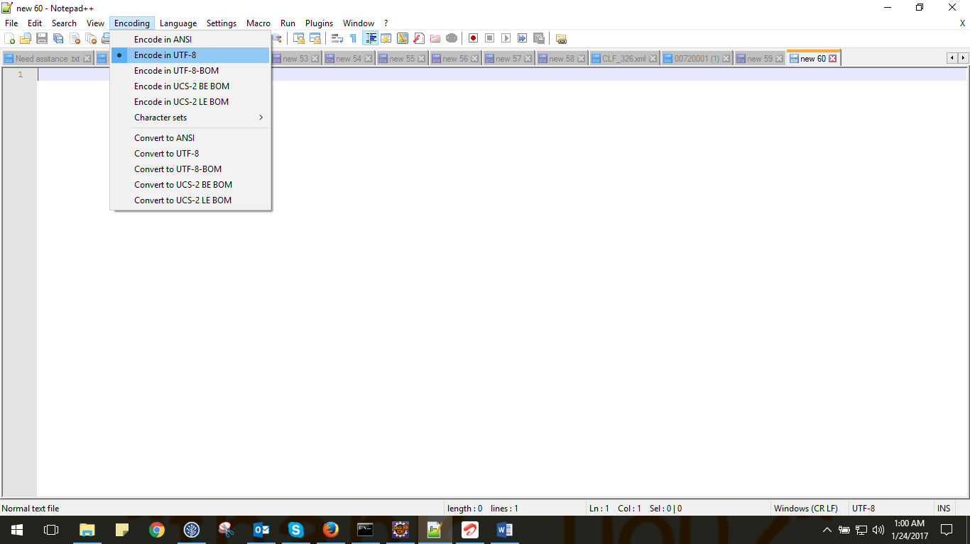

Thank you !